**Bachelor of Engineering (Honours) in Software and Electronic Engineering**

**GMIT Department of Electrical and Electronic Engineering**

**Year 1**

**Industrial Automation**

**Gabriel Farragher 2022**

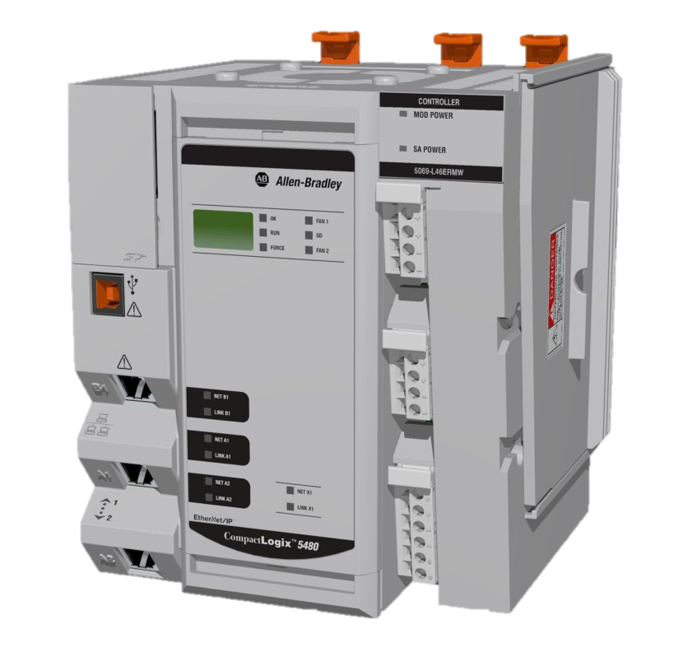

# Student Details:

* Date: January – April 2022
* Module: Industrial Automation
* Student Name:
* Student Number:
* Lecturer: Gabriel Farragher
* Document: Lab Reports

# Table of Contents:

1 Student Details: 2

2 Table of Contents: 3

3 Table of Figures: 3

4 Lab 6 Ex 1 Introduction to Sequence Programming: 5

5 Lab 6 Ex 2 Sequence Programming Continued: 7

# Table of Figures:

No table of figures entries found.

**Notes:**

|  |
| --- |
|  |
|  |
|  |
|  |
|  |
|  |
|  |
|  |
|  |
|  |
|  |
|  |
|  |
|  |
|  |
|  |
|  |
|  |
|  |
|  |

# Lab 6 Ex 1 Introduction to Sequence Programming:

Specification: The Mitsubishi PLC controls a 5-segment sign with the following sequence:

OPEN

**PLC I/O Addresses:**

**Input Schedule:**

* **X1 DI01 iOn_Switch**

**Output Schedule:**

* **Y0 DO00 oBorder**
* **Y1 DO01 oO_Letter**
* **Y2 DO02 oP_Letter**
* **Y3 DO03 oE_Letter**
* **Y4 DO04 oN_Letter**

**[Note: Save PLC software file as: GX W2 L6 Ex 1 GF]**

**Using LL/FBD write the sequence for the following:**

1. Sequence begins when Switch DI01 [X1] is turned On.
2. The Border and the letter O immediately on. Note: The Border remains On all through the sequence but each letter will only be on for 5 seconds.
3. P on for the next 5 seconds then Off,
4. E on for the next 5 seconds then Off,
5. N on for the next 5 seconds then Off,
6. Then the sequence repeats. The sequence will continue until the Sequence Switch DI01 switch is turned Off.

Develop a commented Sequence program for the above.

**Save PLC file as:** **GX W2 L6 Ex 1 GF A**

**Here is some help on where to begin:**

**Note:** M8002 is a special memory bit Mitsubishi PLCs use, and **pulses once** at **power up** or when **you turn simulation on**. It is used to reset or bring any **sequence back to the start**.

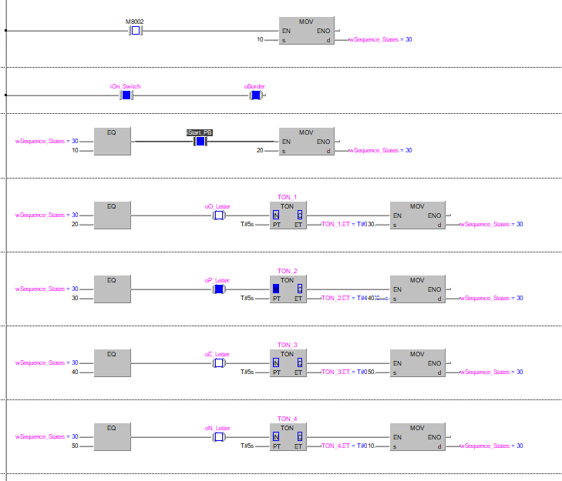

# Lab 6 Ex 2 Sequence Programming Continued:

Modify the above Sequence to operate as follows:

1. Sequence Switch DI01 is turned On.
2. The Border immediately Flashes at 1 second intervals. [Note: M8013 is a flashing pulse bit that will help here].
3. O immediately on for 5 seconds then Off,
4. P on for the next 5 seconds then Off,
5. E on for the next 5 seconds then Off,
6. N on for the next 5 seconds then Off,
7. Then all the letters start flashing for 10 sec. with the border still ‘Flashing’.
8. The sequence will continue until the Sequence Switch DI01 switch is turned Off.

Develop a commented Sequence program for the above.

**Save PLC file as:** **GX W2 L6 Ex 2 GF A**

